Periods of Attic Geometric Art
About 1190 B.C., at the beginning of the archaeological period Late Helladic IIIC, widespread destruction traditionally ascribed to the Dorian invasion ended Mycenaean civilization. Art from the Sub- Mycenaean period reflects the collapse of Mycenaean artistic traditions.

Protogeometric
By 1050 B.C., artists in Attica had almost entirely abandoned or lost Mycenaean figural representation, and instead concentrate on what J.L. Benson calls “circumcurrent and focal tendencies.” In the Protogeometric period, clay- ground and dark- ground (in which the vase is covered in a black glaze) backgrounds are popular, with black- ground became more popular as the era progressed.
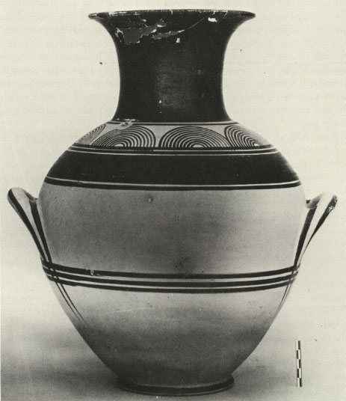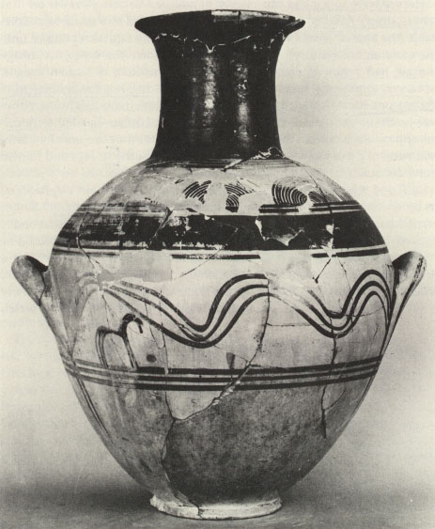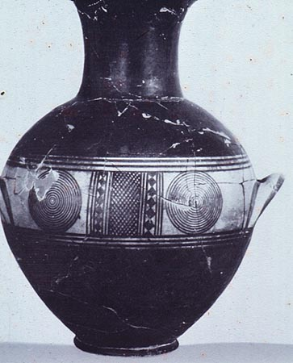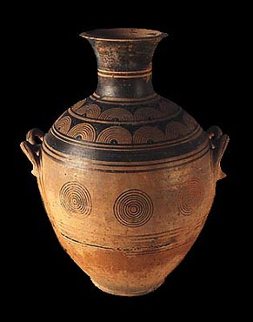

Early Geometric
Throughout the Geometric periods, vase shapes become less rounded, longer and thinner; in the Early Geometric period, beginning around 900 B.C., the neck becomes the focal zone and is often filled with ornamental design.
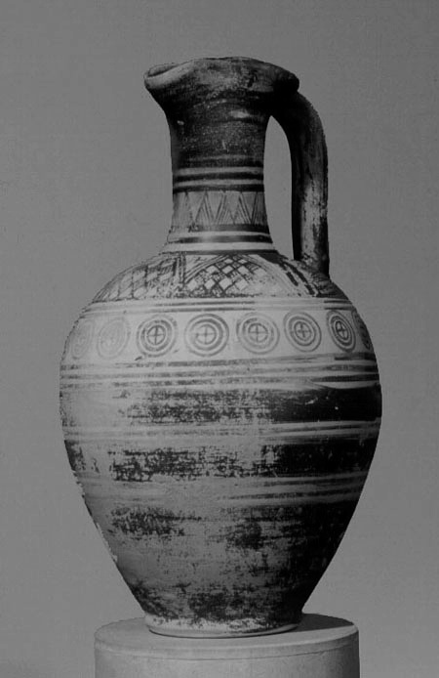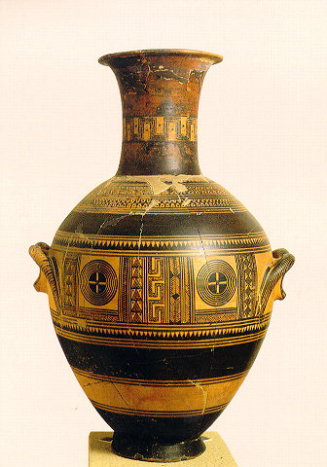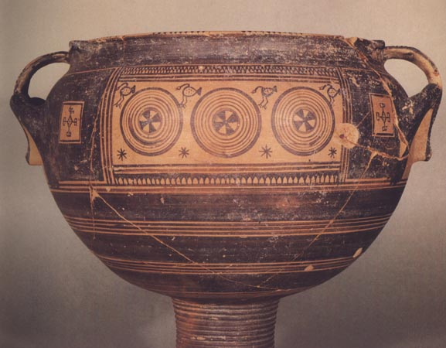

Middle Geometric
Greater elaboration of circumcurrent design and larger ornamental zones characterize the Middle Geometric Period. Black- ground, as opposed to clay- ground, technique was ascendant at this time. The meander became the dominant ornamental motif. Benson attributes the “genesis of the framed picture” to the Middle Geometric II sub- period, with the influence of traditional heraldic schemes transforming ornamental zones into “window panels” with human and animal representations. Arguably, this represents the birth of narrative in Greek plastic art.
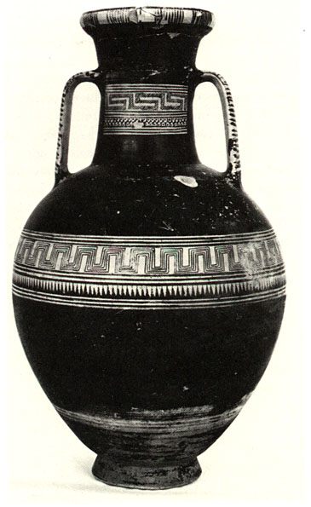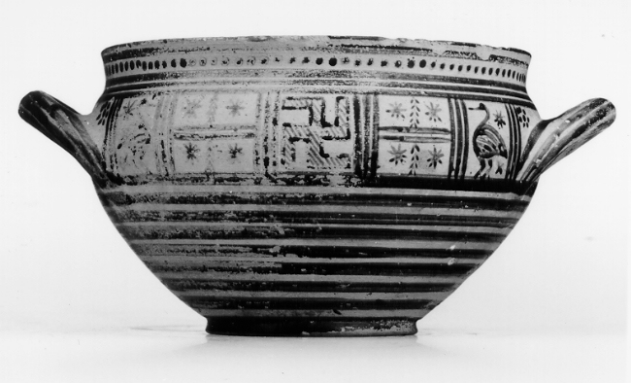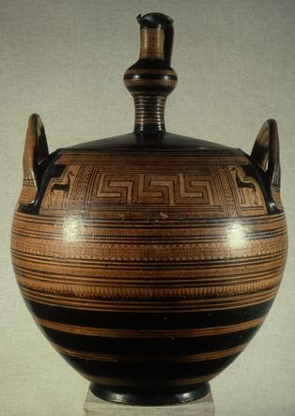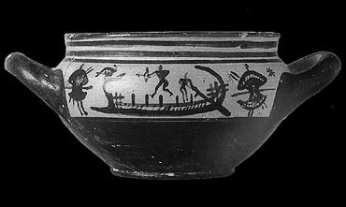

Late Geometric
Around 770, artists of what is called the Dipylon workshop created monumental vases to serve as grave markers; their works were found in the Kerameikos cemetery of Athens. These artists took the window panels of earlier generations and filled them with historical narrative: public funerary ceremonies of the deceased. This is generally considered the beginning of the Late Geometric period, in which figural representation is common. Foreign influence, already evident in the Dipylon prothesis, eventually overwhelmed the style in the 7th century. Clay- ground technique dominated during the late Geometric era, probably due to the high degree of ornamentation at this time.
